Thank you for stepping up to advocate for kids! WSPTA is offering multiple opportunities to LET YOUR VOICE BE HEARD!
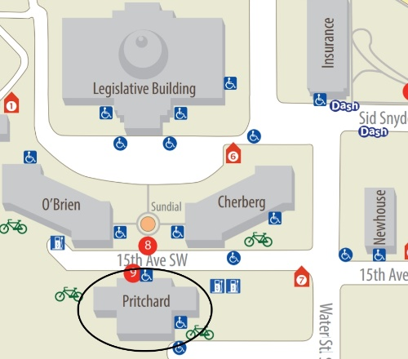
IN PERSON AT FOCUS DAY – Monday, January 29 9am – 2pm – Come to Olympia to meet with legislators about WSPTA-supported issues and let them know what is important to you! Focus Day 2018 is for connecting with your legislators – no rally or speeches this year. Find which Legislative Districts represent your school district on this map, and find those legislators here.
On Focus Day, come to the Pritchard cafeteria (circled), where members of the WSPTA Legislative Committee will greet you and provide our 2018 Legislative Priorities handout, Focus Day Postcards, and campus maps to help make your day successful.
Also on the our advocacy page, you will find a detailed “Issue one-page handout” for each Priority in the drop-down lists under “Legislative Platform.” These one-page handouts are great sources of talking points and can be given to legislators as well.
There are additional resources for coming to Olympia at the end of this email.
ADVOCACY WEEK, January 29 – February 4, is a great opportunity to contact legislators in other ways:
- Got 2 minutes? Reply to a VOTER VOICE Action Alert. Sign up at https://www.votervoice.net/wapta/register
- Got 5 minutes? Find names of the legislators who represent your school district and call the Legislative Hotline to leave them a message: 1-800-562-6000
- Got 10 minutes? Download, print, and mail a postcard to legislators. Find the postcards on our advocacy page. Find mailing addresses for members of the House here and Senators here.
- Got 15 minutes? Send a personalized email to legislators telling them your story and why you care about PTA Priorities.
WSPTA will have a new Priority topic every day during Advocacy Week – sign up for Voter Voice, follow Washington State PTA on Facebook, and check the WSPTA Blog to get weekly updates on WSPTA Priorities and bills.
Thank you again for speaking on behalf of the 1.1 million public school students in Washington!
Nancy Chamberlain
Legislative Director, Washington State PTA
Coming to the Legislature
- http://leg.wa.gov/legislature/Pages/ComingToTheLegislature.aspx
- https://des.wa.gov/services/facilities-leasing/capitol-campus
- Parking info http://leg.wa.gov/legislature/Pages/Parking.aspx
- Capitol Campus Map http://des.wa.gov/sites/default/files/public/documents/campus-map.pdf
- DASH (free shuttle) https://www.intercitytransit.com/bus/routes/dash-101

Coming to Olympia with KIDS – Legislators LOVE to hear stories from students, so here are some tips for making it a happy experience if you bring your kids.
- Arrange a one of several tours of the Capitol campus https://des.wa.gov/services/facilities-leasing/capitol-campus/tours
- Include a trip to an area park https://des.wa.gov/services/facilities-leasing/capitol-campus/parks-and-attractions
- Visit the award-winning Hands On Children’s Museum https://www.hocm.org/
- More ideas https://www.yelp.com/search?find_desc=Kids+Activities&find_loc=Olympia%2C+WA
General Information on the Legislative process, and participating in it
- Overview of the Legislative Process http://leg.wa.gov/legislature/Pages/Overview.aspx

- Citizen’s Guide to Effective Legislative Participation http://leg.wa.gov/legislature/Pages/EffectiveParticipation.aspx

